5)

a)

**package** com.ecommerce.test;

**import** java.time.Duration;

**import** java.util.List;

**import** java.util.concurrent.TimeUnit;

**import** org.openqa.selenium.Alert;

**import** org.openqa.selenium.By;

**import** org.openqa.selenium.JavascriptExecutor;

**import** org.openqa.selenium.WebDriver;

**import** org.openqa.selenium.WebElement;

**import** org.openqa.selenium.WindowType;

**import** org.openqa.selenium.chrome.ChromeDriver;

**import** org.openqa.selenium.support.ui.ExpectedConditions;

**import** org.openqa.selenium.support.ui.Select;

**import** org.openqa.selenium.support.ui.WebDriverWait;

**public** **class** AdvancedLocatingElements {

**public** **static** **void** main(String[] args) **throws** InterruptedException {

// Basic configuration

WebDriver driver = **new** ChromeDriver();

demoExternalElementsNewTab(driver);

}

**static** **void** demoExternalElementsNewTab(WebDriver driver) **throws** InterruptedException {

String baseUrl = "File:///C:\\Users\\Thaneeru Anil Kumar\\eclipse-workspace3\\hello-selinium\\src\\main\\resources\\test.html";

driver.get(baseUrl);

// driver.manage().timeouts().implicitlyWait(10, TimeUnit.SECONDS);

Thread.*sleep*(10000);

driver.switchTo().newWindow(WindowType.***TAB***);

driver.navigate().to("https://www.google.com?q=flowers");

}

}

Output:

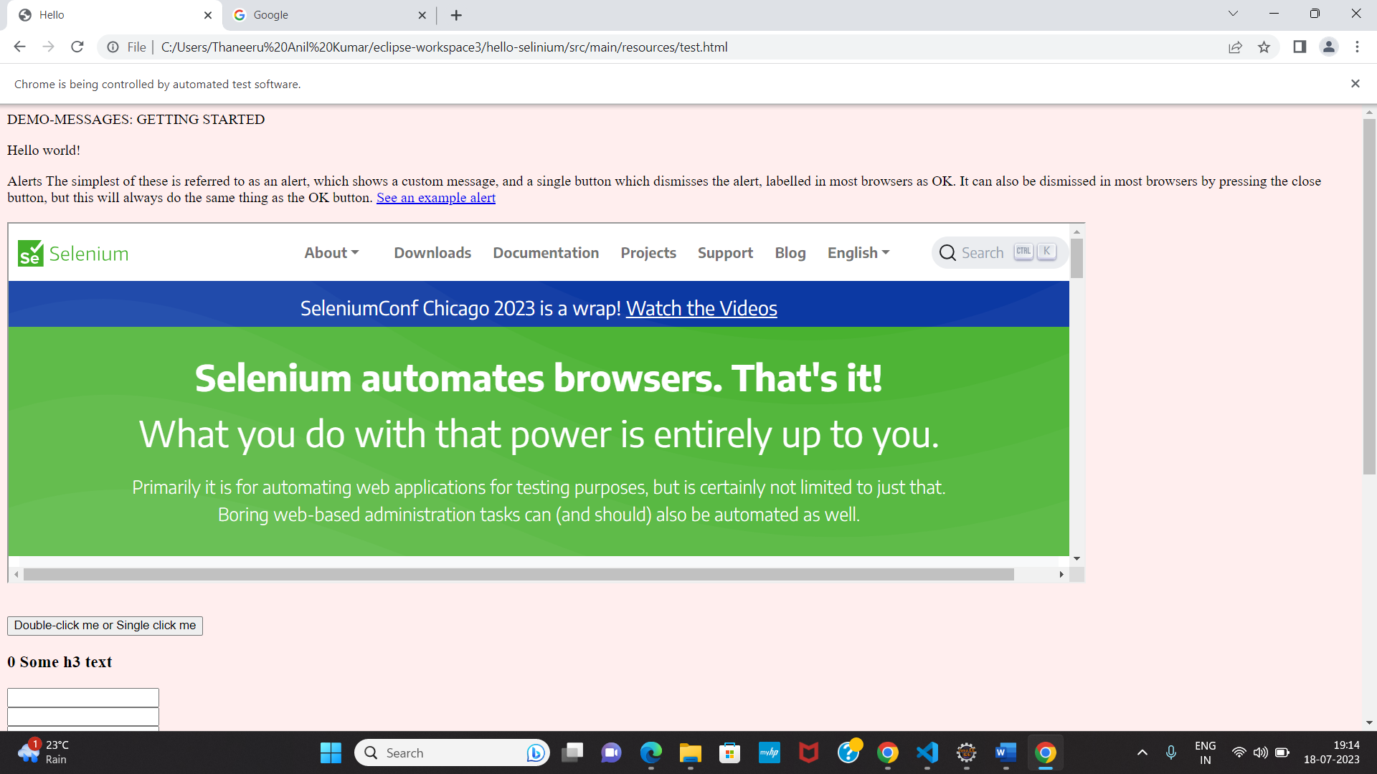

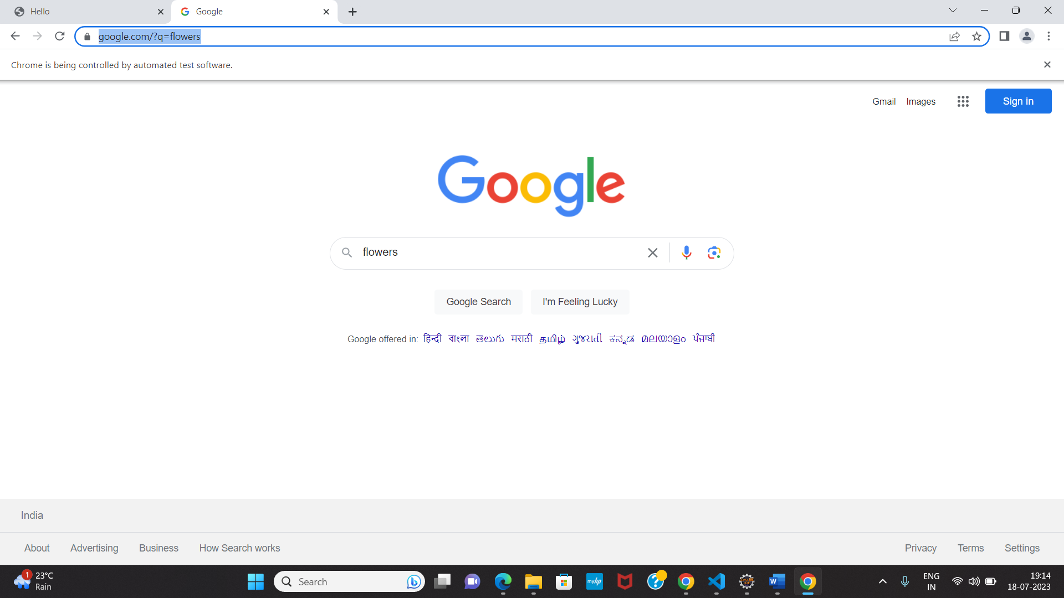

b)

**package** com.ecommerce.test;

**import** java.time.Duration;

**import** java.util.List;

**import** java.util.concurrent.TimeUnit;

**import** org.openqa.selenium.Alert;

**import** org.openqa.selenium.By;

**import** org.openqa.selenium.JavascriptExecutor;

**import** org.openqa.selenium.WebDriver;

**import** org.openqa.selenium.WebElement;

**import** org.openqa.selenium.WindowType;

**import** org.openqa.selenium.chrome.ChromeDriver;

**import** org.openqa.selenium.support.ui.ExpectedConditions;

**import** org.openqa.selenium.support.ui.Select;

**import** org.openqa.selenium.support.ui.WebDriverWait;

**public** **class** AdvancedLocatingElements {

**public** **static** **void** main(String[] args) **throws** InterruptedException {

// Basic configuration

WebDriver driver = **new** ChromeDriver();

demoExternalElements(driver);

}

**static** **void** demoExternalElements(WebDriver driver) **throws** InterruptedException {

String baseUrl = "File:///C:\\Users\\Thaneeru Anil Kumar\\eclipse-workspace3\\hello-selinium\\src\\main\\resources\\test.html";

driver.get(baseUrl);

// driver.manage().timeouts().implicitlyWait(10, TimeUnit.SECONDS);

Thread.*sleep*(10000);

driver.findElement(By.*linkText*("See an example alert")).click();

// alert will appear now, may be in 10 secs

WebDriverWait wait = **new** WebDriverWait(driver, Duration.*ofSeconds*(10));

// Wait for the alert to be displayed

wait.until(ExpectedConditions.*alertIsPresent*());

// Store the alert in a variable

Alert alert = driver.switchTo().alert();

System.***out***.printf("\n alert text is %s \n", alert.getText());

Thread.*sleep*(10000);

alert.accept();

}

}

Output:

